Case study 1

Big Data Security Issues at "DataSphere Corporation"

Instructor: Nadia AL-Rousan
Done by :
Jana Abdullah
Sasha Shapsough
Jameel Alas’ad
Sabeen shoufieen

Introduction
Datasphere Corporation is a top company that offers data analytics services to various industries, such as healthcare and finance. Recently, the company moved to a cloud-based big data system to improve scalability and lower costs. However, this change brought some security issues, especially the risk of cyberattacks in a shared (multi-tenant) environment.

Key Concepts
→ Big Data
“Big data” means using special tools to work with huge amounts of data that normal software can’t handle.
→ DDoS Attack
A DDoS (Distributed Denial of Service) attack floods the system with so much traffic that it stops working for real users.
→ Multi-Tenancy
This is when different clients share the same cloud system. It saves money, but if security is weak, one client’s problem could affect others

The Incident

On Monday at 10:32 AM, DataSphere's monitoring system detected a sudden spike in traffic coming from hundreds of different IP addresses. A botnet made up of hacked IoT devices was used to flood DataSphere’s public APIs with fake data requests all at once. This massive traffic overloaded the company’s load balancers and Hadoop-based storage systems, causing slowdowns and eventually blocking access for all clients. The attackers took advantage of an open port in the cloud firewall that hadn’t been properly secured.

The following graph illustrates the DDoS attack scenario on DataSphere’s cloud infrastructure, highlighting how the attack affected system traffic and availability:

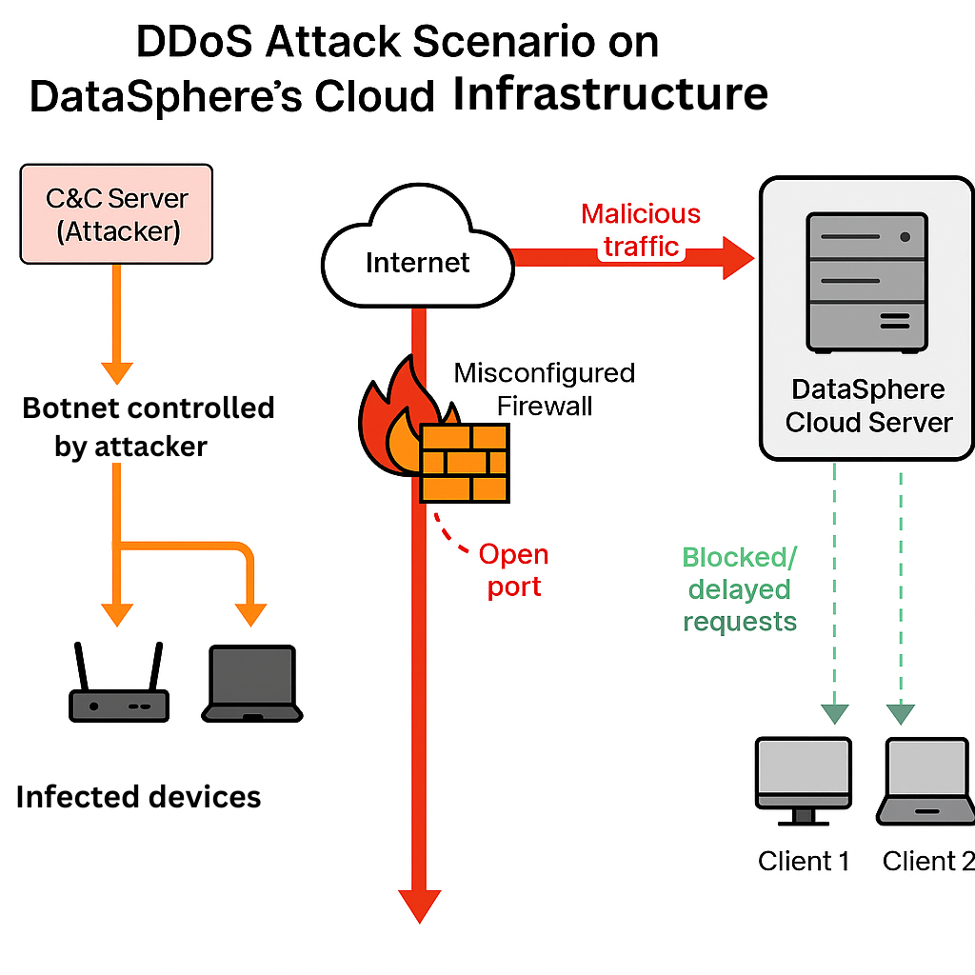
Impact Analysis

- Service Outage: Core services, including real-time dashboards and data upload portals, became unavailable (ex: The system was down for 5 hours.)
- Client Disruption: Clients in critical sectors like finance and healthcare faced major delays, affecting decision-making and operations (ex: About 30 clients couldn’t access their data during that time.
- Reputational Damage: The incident led to client dissatisfaction and loss of trust in DataSphere's security capabilities (One big client paused their contract because of this.)

Data Breach Assessment
While the DDoS attack was happening, attackers also tried to:
- Scan ports to find more entry points.
- Guess login passwords (brute-force attack).
- They didn’t steal full data but got some metadata — like project names or data types.

Affected clients included
- A healthcare analytics client
- A major retail chain
- A financial forecasting service provider

Security Measures
Short-Term Fixes:
- Block the IP addresses sending the attack traffic.
- Close unused ports so attackers can’t use them.
- Limit the number of requests a user can send in a short time.
Long-Term Strategies:
- WAF (Web App Firewall): A smart filter that blocks attacks before they reach the app.

- DDoS Protection Services: Tools that absorb fake traffic (like Cloudflare).

- Zero Trust: Don’t trust any user by default — even inside the system.

- RBAC(Role-Based Access Control) : Only let users access the data or tools they need — no more , via Each role gets specific access rights. For example:
- A Data Analyst can view reports but can't change system settings.
- An IT Admin can manage user accounts and settings.
- A Manager can see team performance data but not technical logs

- Encryption: Scramble the data so if someone gets it, they can’t read it.

- Penetration Testing: Simulate attacks to find weak spots.

- Employee Training: Teach staff to configure systems correctly and avoid mistakes.

Similar Scenario
To understand how other organizations have faced similar threats, consider the case of GitHub.
What Happened:
On February 28, 2018, GitHub (a website used by many developers) was hit by one of the biggest DDoS attacks ever. The attacker sent a huge amount of traffic — 1.35 terabits per second — and lasted about 20 minutes. Even though GitHub was ready for attacks, this one was so big it still caused problems for a short time.
What We Can Learn:
- Be Prepared: Even companies that are well-protected can still be affected by new and stronger attacks.
- Have Strong Systems: It’s important to build security systems that can grow and adapt to stop very large attacks like this one.

Comparison
By comparing the two incidents, we can see how preparation makes a big difference in handling cyberattacks.
Both GitHub and DataSphere were attacked using DDoS, which floods a system with too much traffic. GitHub was more prepared and stopped the attack fast, but even their strong defenses were tested. DataSphere, on the other hand, had weaker protections, so the attack caused more damage. This shows why it's important to stay ready and improve security regularly — no company is 100% safe.

 Conclusion
The attack shows that cloud systems can be risky if not protected well. Even a small mistake can cause big problems like downtime and lost clients. So, security must be part of everything — from planning to daily operations.

References
- OWASP Foundation. (2024).
The Open Worldwide Application Security Project (OWASP). Retrieved from https://owasp.org
- Cloudflare. (2024).
DDoS Attack Resources. Retrieved from https://www.cloudflare.com/learning/ddos/
- National Institute of Standards and Technology (NIST). (2023).
Cybersecurity Framework. Retrieved from https://www.nist.gov/cyberframework
- Amazon Web Services (AWS). (2024).
Security Best Practices. Retrieved from https://aws.amazon.com/whitepapers/security-best-practices/
- Apache Software Foundation. (2023).
Hadoop Security Documentation. Retrieved from https://hadoop.apache.org/docs/current/hadoop-project-dist/hadoop-common/SecureMode.html
- GitHub. (2018).
GitHub DDoS Attack Incident Report. Retrieved from https://github.blog/2018-03-01-ddos-incident-report/

